**Thetis Blockmatrix White Paper**

**Authored by James Halldorsson, Lead Developer and CEO.**

The Thetis Blockchain platform is a new take on Blockchain and Cryptocurrency technology that plans to introduce a plethora of new features and optimizations in the Blockchain space. The Thetis project will be the first ever commercial Block matrix technology. In this White Paper I will give a brief description of what exactly a block matrix is and why it will revolutionize the blockchain industry

A Block matrix, or Datablock matrix is a new, innovative idea in the blockchain industry, essentially a block matrix is an ecosystem of several different blockchains that are all interconnected and communicating with each other's individual blockchains. Each individual account in the Thetis Ecosystem has its own blockchain, this account can hold several unique data types that are owned and possessed by the associated account, including token wallets, NFTs and encrypted blockchain assets.

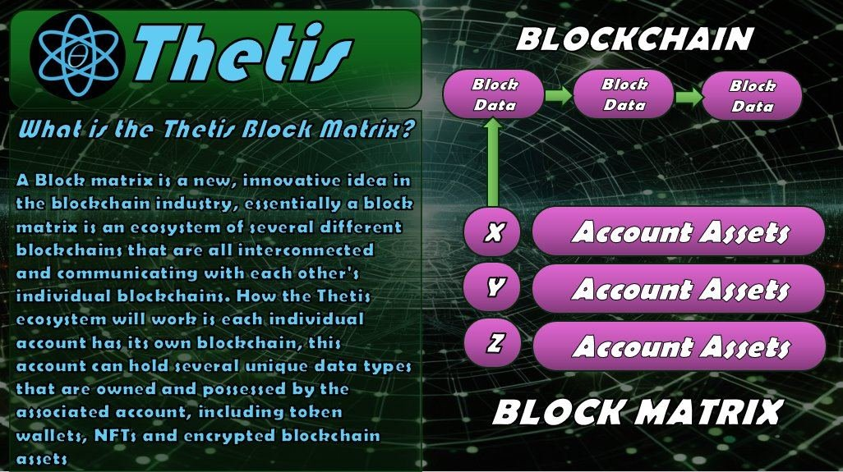

The Block Matrix is a concept for a cryptographic blockchain technology that utilizes multiple asymmetric blockchains to alleviate the downsides of a singular chain for networking, commerce, financial and cybersecurity applications. Most of the blockchain technologies utilized for cryptocurrency and various other digital ledger applications exist on a single blockchain, essentially a linked list of digital ledgers and smart contracts that require previous blocks processed on the blockchain to be verified and cryptographically confirm the legitimacy of the current digital ledger or smart contract. The weaknesses with this form of architecture are becoming more apparent as the blockchain world begins to embrace non fungible tokens (NFTs) and as public adoption of these technologies becomes more prevalent, weaknesses like long confirmation times sometimes spanning the length of hours or even days to verify a block on the blockchain, or exorbitant "Gas fees" required to pay those mining the blockchain using verification algorithms for their time and computational contribution to the verification process.

The primary reason for these ridiculous fees is the fundamental concept blockchains like Ethereum and bitcoin rely upon for verification of a new block on the blockchain. To better explain this phenomenon, we need to look at the intrinsic function of a blockchain such as the aforementioned Ethereum and bitcoin blockchains and how they operate. A blockchain is again essentially a linked list of cryptographic hexadecimal addresses which are linked together in a chain of "Blocks" that must verify all previous blocks on the chain before a transaction is approved. What this means is every time a transaction occurs on the blockchain, it needs to trace back all the blocks on the blockchain to the initial genesis block on that chain to approve the current transaction. Essentially every time to send someone Ethereum or trade some cryptographic asset like an NFT, the verification algorithm has to go through billions of verification checks back to the initial genesis block on the blockchain, which is computationally expensive and thusly economically expensive in fees to pay the miner and service providers their cut of the pie. This occurs not once when you utilize blockchain technology, but every time anything is added to or processed on the blockchain it must trace and verify all prior blocks, billions of blocks, which is not streamlined and exhaustive on any energy infrastructure behind the computational systems doing this.

So... what is the solution?

Enter the block matrix.

The concept of the block matrix is to divide the computational load on each transaction within a cryptographic ecosystem by using arrays and matrices instead of a singular linked list which spans billions of blocks back to the genesis block. How can this be achieved? Each participant within the ecosystem is their own blockchain E.g. All the individual nodes of the network, the "wallets" that hold cryptographic assets and their representative addresses are instead of represented as blocks on a blockchain, they themselves would be blockchains that hold a linked list of addresses representing assets. This creates an ecosystem of parallel yet asymmetric blockchains that all share a similar architecture and thus are natively compatible with one another. Instead of having to trace back to the genesis block of the entire blockchain every time a transaction occurs simply to verify it, only the individual blockchains involved with the transaction would be required to be verified.

Once verified, the Asset address of the asset being transacted simply swaps over to the new blockchain after it is verified. This requires very few steps in comparison to verifying billions of blocks to approve a transaction, as few as a single block on each of the participating blockchains engaged with this transaction. This would significantly reduce the time and computational power required to verify cryptographic transactions, in turn reducing the cost economically and making a block matrix a superior cryptographic technology for exchanging and storing cryptographic assets.

Let's say a transaction occurs between two accounts in the ecosystem, this transaction would occur on two separate blockchains, the transactor and the recipient each have their own blockchains, these blockchains would both validate the transaction before assets are moved. On a traditional blockchain, each block is linked to all prior blocks in a series of hashes that encrypt the next block based on the previous hash of prior blocks. A wallet application communicates with a decentralized node network through RPCs adding to the existing blockchain. Instead of tracing back millions or billions of blocks for each transaction, only the blocks of data that are relevant to the current transaction are computed, while remaining safe and secure, due to unique cryptography for each account and the fact that all data is compressed. Legacy blockchains are on their way out, since all currently utilized blockchains are using SHA256 which is at threat by AI and quantum computing within 10 years. Thetis blockchain uses SHA512 which will futureproof it

When a transaction occurs on the Thetis Blockmatrix, the Transacting account first creates a data block containing the transaction information and then validates and verifies that this block is legitimate on its own blockchain. Once this block has been verified and added to the initial blockchain from the transacting body, a duplicate block is created and sent to the recipient account, the recipient account then validates and verifies the block on the receiving end and adds this duplicate block to it’s blockchain. The sender’s blockchain will indicate that it has sent some data to the recipient and the recipient’s blockchain will verify that it has received the associated information.

After a transaction has been completed and the duplicate block data is successfully received, verified and added to the recipient blockchain, ownership of the associated asset is transferred to the recipient account. The recipient account queries a cloud storage database that holds all EBA’s (encrypted blockchain assets) in no distinct order, this query returns all the account owner’s assets, including the assets added in prior transactions, decrypting them on the recipients end at this time.

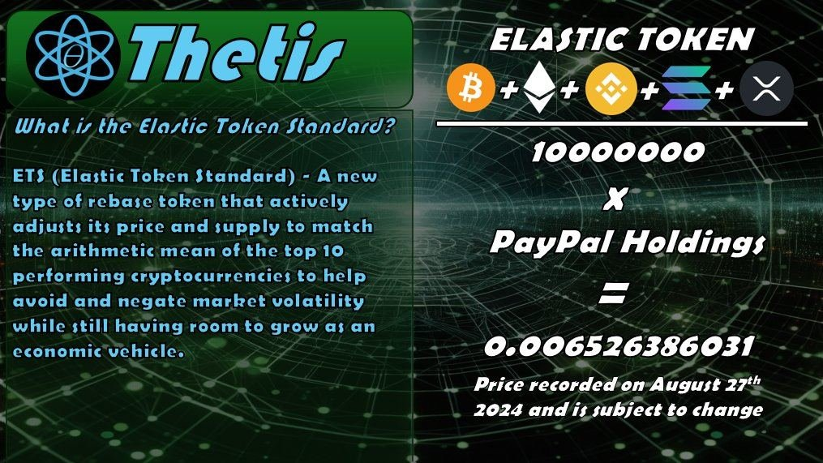

ETS (Elastic Token Standard) - A new type of rebase token that actively adjusts its price and supply to match the arithmetic mean of the top 10 performing cryptocurrencies to help avoid and negate market volatility while still having room to grow as an economic vehicle.

Redefining Liquidity - By having an associated PayPal holdings account that has the equivalent value of the market capitalization of all ETS tokens in existence, ETS tokens can easily and seamlessly be liquidated into USD fiat funds at any time. This concept of having a 100% liquid asset with a fiat liquidity pool built directly into the Blockmatrix ecosystem will make the possibility of mass adoption of cryptocurrency more viable, as users of the Thetis Blockmatrix are able to immediately buy and sell tokens without a third party in an instant and can use ETS and other tokens in the real world to make purchases and investments directly from their token balance.

ETS tokens in greater detail:

Every crypto token’s value is derived from its total market capitalization divided by the quantity of that token aka, the total supply

example:

V = m/s

Thusly, these two factors can augment the value of V, given that:

A change of Δm or a change in Δs, if the supply is fixed, it is Δm/s if the supply is not fixed it is Δm/Δs

Obviously, this introduces a problem, huge fluctuations can occur in an instant if Δm and Δs are not stabilized, leading to a highly volatile market where stability and ordinance is seldom seen.

Introducing ETS tokens (Elastic Token Standard), a new way of introducing stability by diminishing the volatility of the market through the creation of an elastic token that takes the arithmetic mean of the other top performing markets and adjusts the total supply by this factor to attempt and normalize market volatility and provide a more stable economic vehicle that still has room to economically appreciate over time.

Let’s look at that equation again:

V=Δm/Δs

In the case of ETS tokens we normalize the volatility of Δs by adjusting it to be the arithmetic mean of the top 10 performing cryptocurrencies:

V=Δm/Δs becomes V=Δm/A where A = 1/n(n)Σ(i=1)(ai=10)

V=Δm/1/n(n)Σ(i=1)(ai=10)

The total Market Capitalization (Δm) will be divided the adjusted supply (1/n(n)Σ(i=1)(ai=100)) which will be used to then determine a going cost per ETS token. The result of this arithmetic should be a normalized average value which essentially takes the middle road of all other crypto tokens in the top 10, in this way, if volatility affects tokens on the market at either end of the distributive bell curve, ETS tokens should remain relatively stable in comparison, this continuous adjustment of supply will minimize loses and maximize the potential for economic growth of the vehicle.

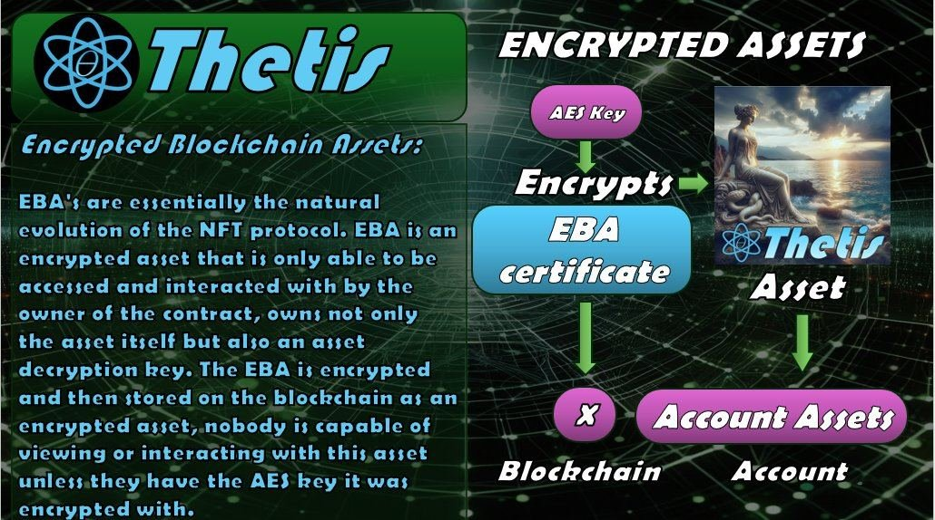

EBA (Encrypted Blockchain Assets) - EBA's are essentially the natural evolution of the NFT (Non-Fungible Token) protocol. An NFT is a digital receipt that indicates ownership and points towards a specific hyperlink, the wallet which holds this digital receipt is consider the owner of the attached asset at the hyperlink. This hyperlink is, however, accessible to anyone who has the hyperlink, though they may not be the owner of the asset, the are able to interact with the asset freely at their discretion. An EBA (Encrypted Blockchain Asset) shares similarities with the idea of an NFT, however, an EBA is an encrypted asset that is only able to be accessed and interacted with by the owner of the contract, whom has in their possession not only the asset itself but also an asset decryption key. The EBA is encrypted and then stored on the blockchain as an encrypted asset, nobody is capable of viewing or interacting with this asset unless they have the AES key it was encrypted with, when someone transfers this asset to someone else, ownership is also granted to the recipient, and they are capable of now encrypting and decrypting the asset at will. There are many use cases for this technology outside of the initial imagined use cases of an NFT, making it a superior technology that could be utilized in application ranging from security, anonymity and notarization/officiation of documents and other file types.

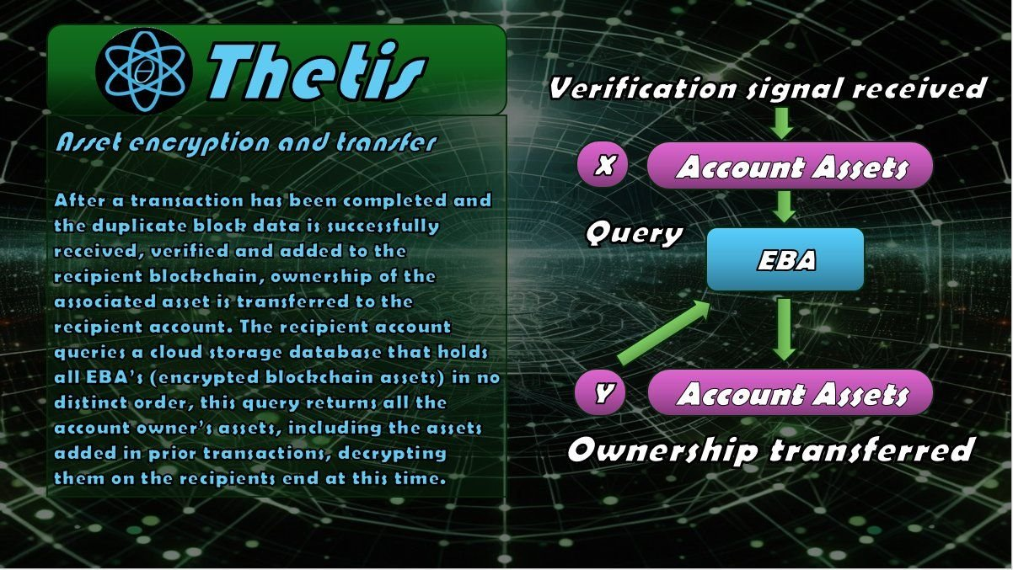

An EBA is an encrypted asset that is signed and secured by an associated account, the certificate is similar to an NFT, except that an NFT is not a protected asset, it's just a receipt that points to an external hyperlink and says, "I own this thing". An EBA differs from an NFT because an EBA isn't just a receipt pointing to a hyperlink somewhere on the internet, it's an encrypted asset that is completely inaccessible by anyone accept the contract holder, who also holds an equivalent symmetric encryption key. Let’s say you're an artist and you want to create digital artwork that is scarce and rare and only want it displayed at digital art galleries, an EBA is a good solution for this use case, as the asset could be encrypted and then decrypted to show the art, then encrypted again. There are many different potential use cases for this technology beyond just the traditional NFT space, like officiation and notarization of documents or secure transfer of encrypted assets that contain personal or sensitive information. This technology could completely revolutionize how people, companies and governments trade and store documents, images, videos and sound files with one another. The possibilities are endless, this is one of many unique technological advantages that will be exclusive to Thetis.